NA Graduate training program

QE Foundation KBA-instruction guidelines



**Instructions to take up the QE Foundation KBA on My Learning portal**

Please follow the below steps to launch the assessment through My Learning portal.

1. Login to <https://onecognizant.cognizant.com/>

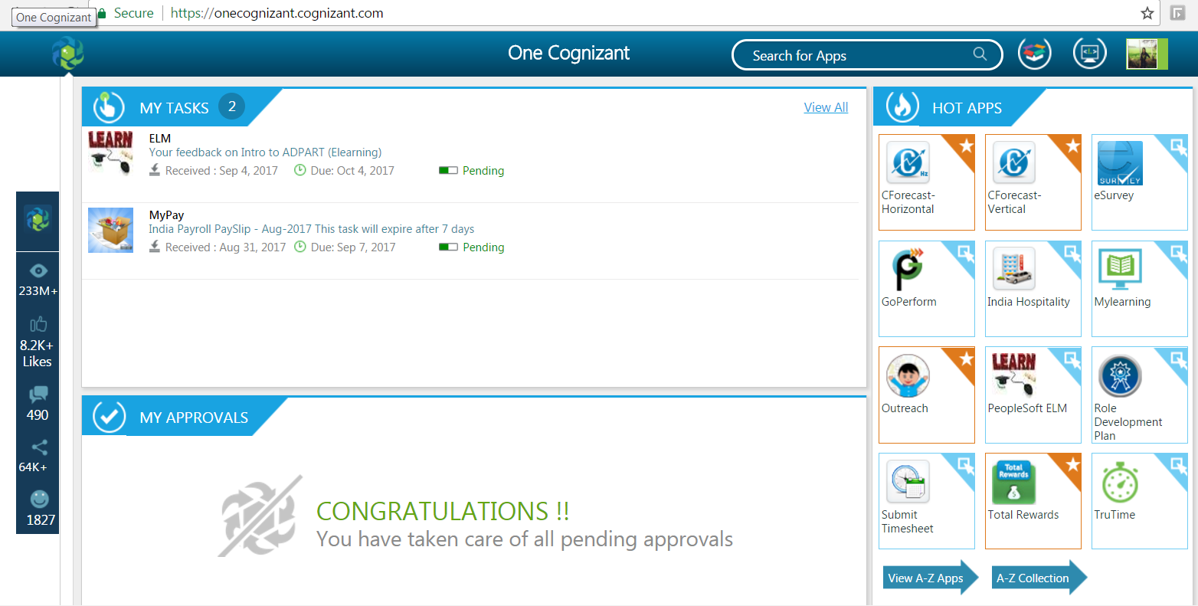

1. Search for Cognizant Learn app in the ‘Search for Apps’ field. Click on Cognizant Learn app.



1. User will navigate to below screen.

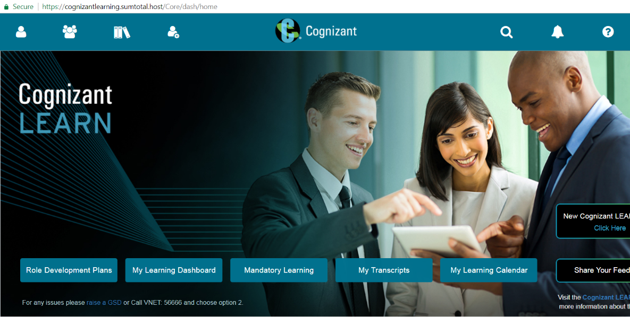

1. Search for the assessment code by clicking on the Search icon on top right side of the screen.



* 1. 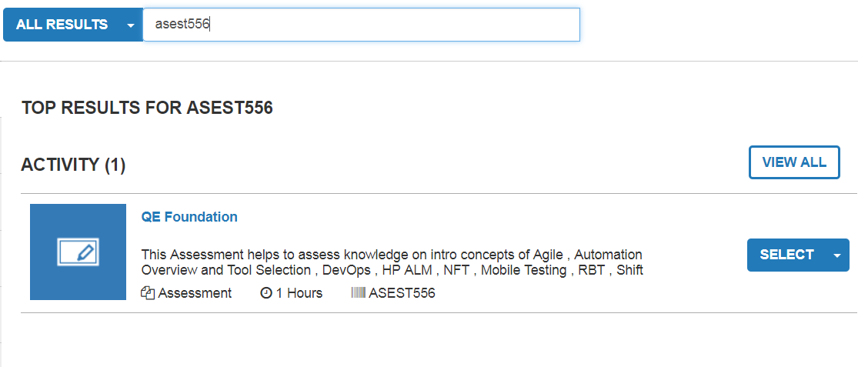

1. Click on the drop down icon in SELECT button. Click on Register in the drop down.

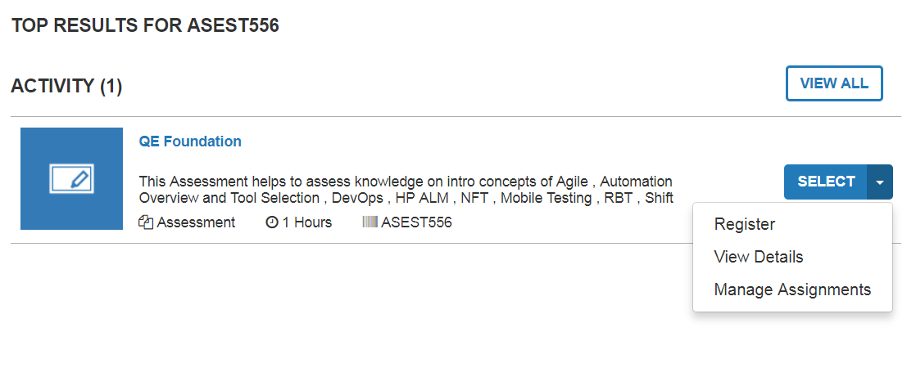

1. User will be able to see below screen after clicking Register. Click on Submit button.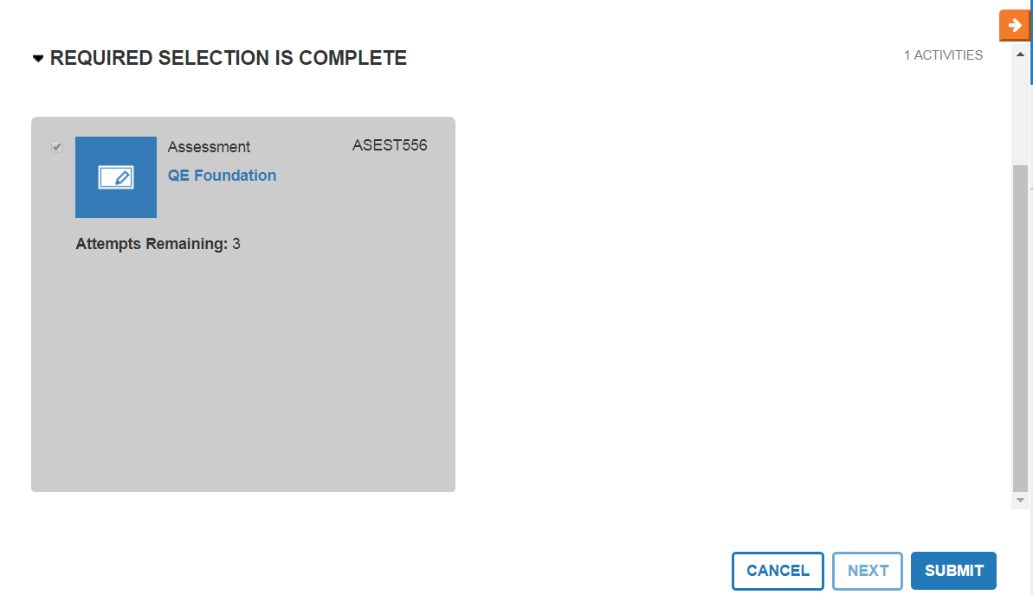
2. Click on Start button.

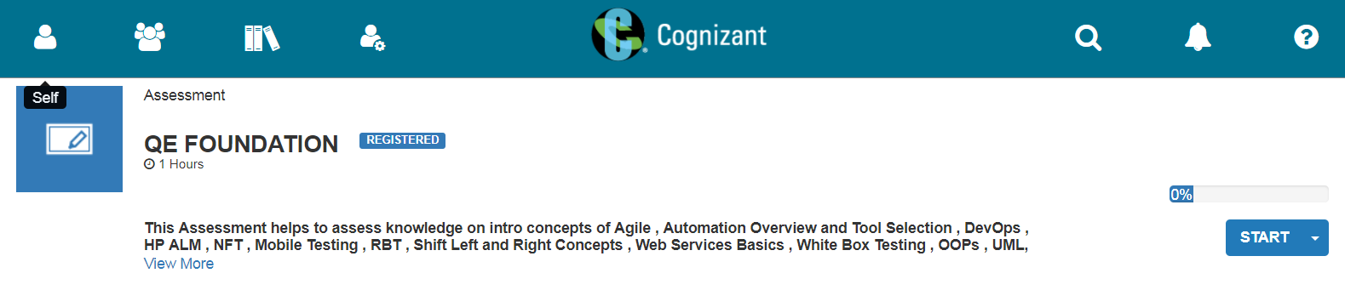

1. Click on Agree button and start your assessment.